Unisheets Documentation

Contents

Be a Google Developer 2

Adding Sheets to your API Library 2

Create a Project 3

Create & Credentials for your Project 5

# Be a Google Developer

## Adding Sheets to your API Library

1. Go to [https://console.developers.google.com](https://console.developers.google.com/)

2. In the side menu, pick Library

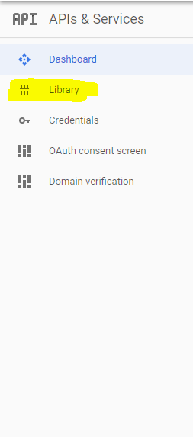

3. Search for google sheets API

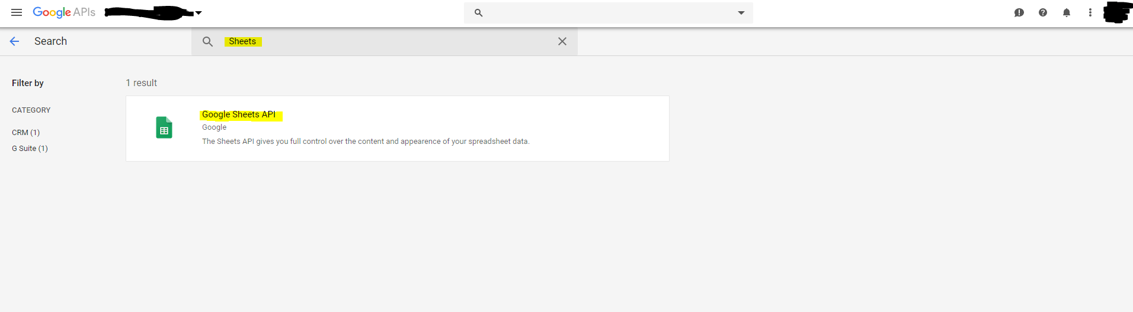

4. Click in the API to install it (Notice it will say “Enable” instead of “Manage”

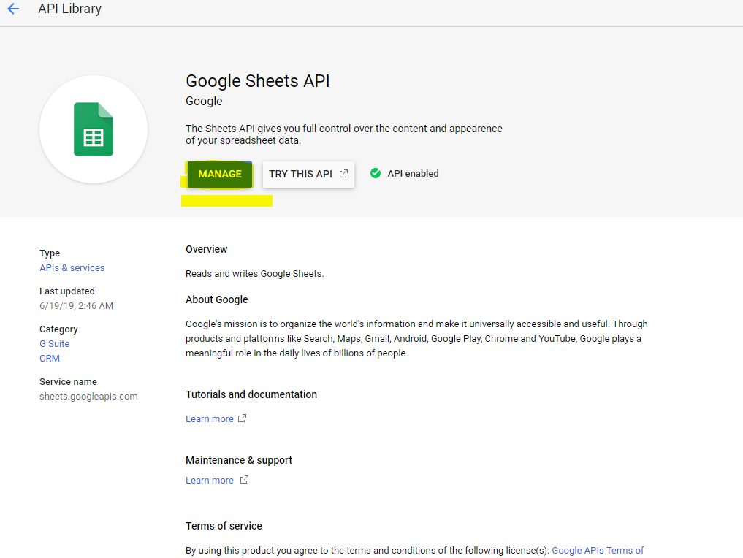

## Create a Project

1. Click the arrow at the top left menu

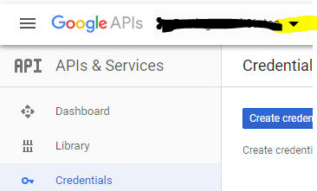

1. Select “NEW PROJECT”

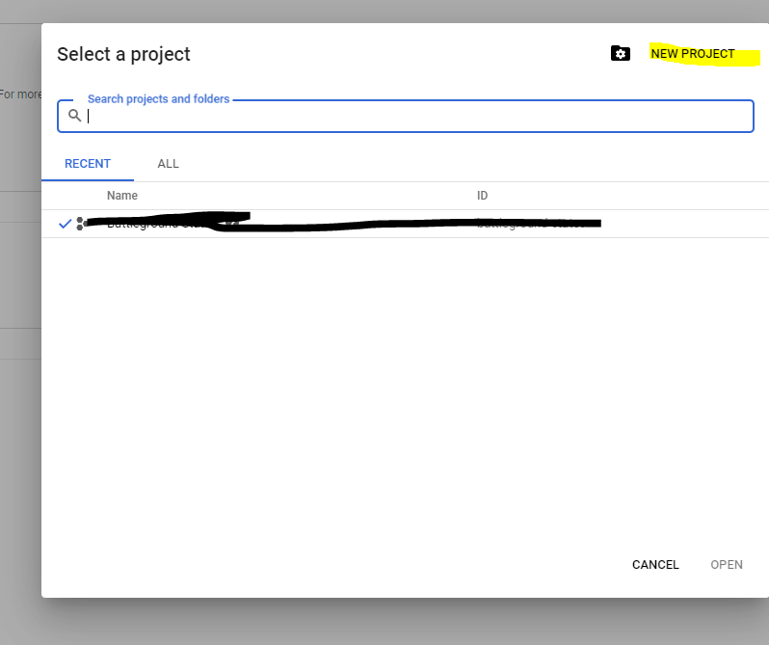

1. Give your project a name and hit “Create”

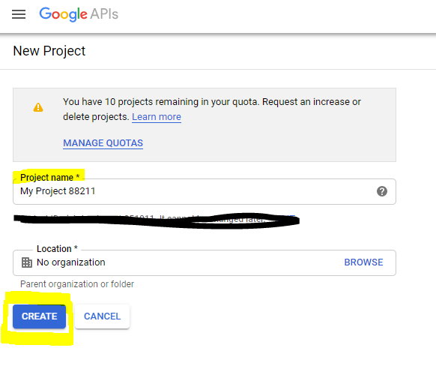

## Create & Credentials for your Project

1. Go to googles [developers console](console.developers.google.com/) >> Credentials (side menu)

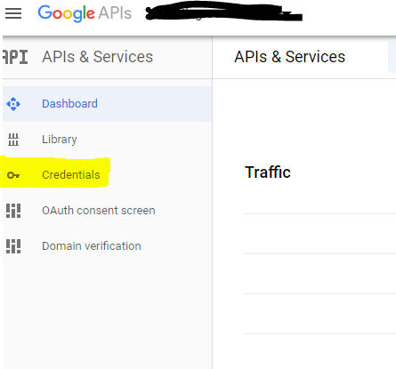

2. Click the “Create Credentials” button and choose “OAuth client ID”

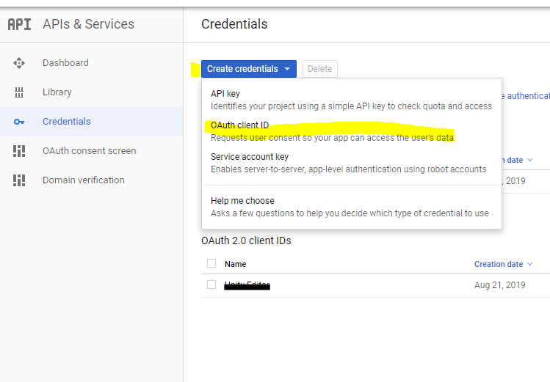

1. Choose “other” as the app type and pick a name for your auth client ID (any will do). It is a good practice to choose the same name as your project name. Click the “Create” button when finished.

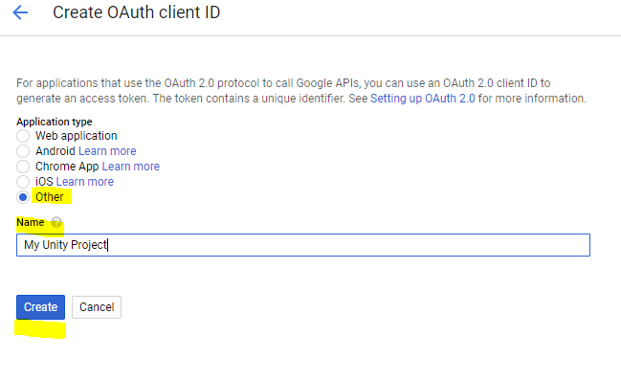

4. Your credentials will now be under the ID’s list. Click on it.

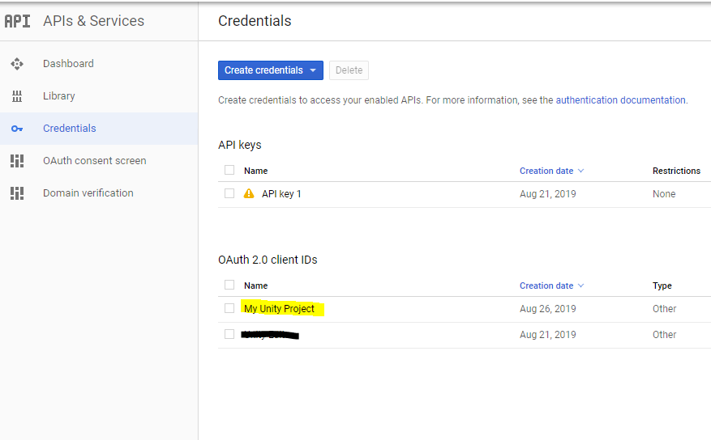

5. Choose “DOWNLOAD JSON” to download your credentials localy.

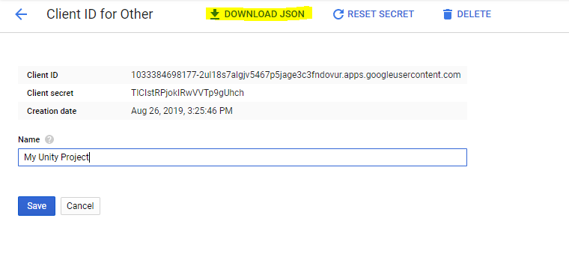6. Place your credentials wherever you want, but remember where!

# In Unity

## Validating the Service Component

1. In Unity, place the GoogleSheetsService script in a scene.

2. Give the application a name, any will do.

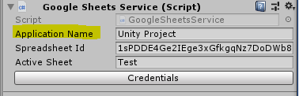

1. Get the spreadsheet ID for the spreadsheet you wish to work on and paste it here.

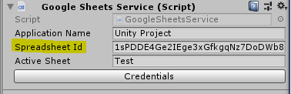

4a. Locate the spreadsheet your wish to work on and open it in your google drive.

4b. Copy the URL from your spreadsheet  
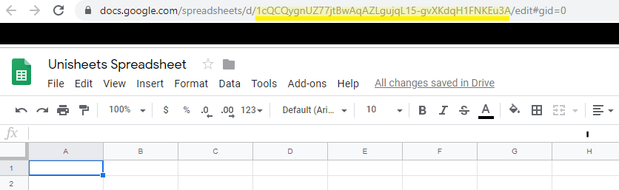

5. give the name of the sheet you wish to work on.

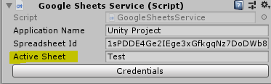

6. use the dialog to find your credentials file

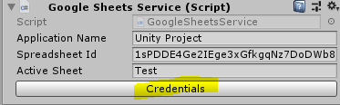

## Working with the Service Component

GoogleServices.GoogleSheetsService Class Reference

### Public Member Functions

* IList< IList< Object > > **GetData** (string range)

*Gets data from a given range.*

* object **GetCellData** (string cell)

*Gets data from a specific cell*

* void **WriteRow** (string startingCell, IList< Object > rowData)

*Inserts (overwrite) a row anywhere*

* void **WriteData** (IList< IList< Object >> values, string startCell)

*Writes data starting from a specific cell*

### Public Attributes

* string **applicationName** = "Unity Project"
* string **spreadsheetId** = "Your Sheet ID"
* string **activeSheet** = ""

### Member Function Documentation

#### object GoogleServices.GoogleSheetsService.GetCellData (string cell)[inline]

Gets data from a specific cell

##### Parameters

|  |  |
| --- | --- |
| *cell* | given as "X1" |

##### Returns

returns the object contained in the cell

#### IList<IList<Object> > GoogleServices.GoogleSheetsService.GetData (string range)[inline]

Gets data from a given range.

##### Parameters

|  |  |
| --- | --- |
| *range* | The range given as "X1:Y2" |

##### Returns

rows[Columns][Cell]

#### void GoogleServices.GoogleSheetsService.WriteData (IList< IList< Object >> values, string startCell)[inline]

Writes data starting from a specific cell

##### Parameters

|  |  |
| --- | --- |
| *values* |  |
| *startCell* | given as "X1" |

#### void GoogleServices.GoogleSheetsService.WriteRow (string startingCell, IList< Object > rowData)[inline]

Inserts (overwrite) a row anywhere

##### Parameters

|  |  |
| --- | --- |
| *startingCell* | given as "X1" |
| *rowData* |  |

# References

API Docs - <https://developers.google.com/sheets/api/>